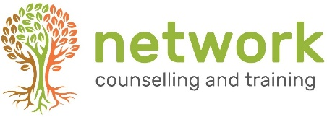
APPLICATION FORM

‘A WAY OF BEING’ (AWOB21)
An Introduction to Person-Centred Counselling
Venue: Network Training, Elm Park, Filton, Bristol BS34 7PS (or online via Zoom)
Wednesday 6th January – Wednesday 31st March 2021 (half-term break 16th February)
from 6.30 – 9.30 pm
Course fee £260 (includes a £25 non-returnable deposit).
Can be paid in one lump sum or three instalments.
Closing date for applications: Friday 18th December 2021.
(late applications will be considered subject to the availability of places)

Name
Address
Post code
Telephone / Mobile
Email address

1. Personal Statement
Please tell us about yourself and why you are applying for this course, with reference to your experience in helping and supporting others: (no more than 300 words)

Continued over …

Health /additional support *
If you have an ongoing health condition, a mental health diagnosis, a disability or have learning support needs, we recommend that you let us know as early as possible. We will contact you to discuss your requirements in relation to the selected course, and discuss the support and facilities available, this will ensure that we are able to offer you the support you need.

* As part of the counselling course training, as well as learning counselling skills and theory you will be invited to reflect upon your own life. This can feel personal and revealing. We are looking for you to be reasonably emotionally robust. We suggest you consider the impact that significant life experiences (such as a close personal bereavement, mental health issues, personal illness or recovering from addiction) have had on your life, and how these may impact you whilst on a counselling/listening course. If necessary, we encourage you to join the training when time to rebalance has passed and you feel ready for the course.

Please return completed forms to the Training Coordinator at the address below
or email to: training@network.org.uk

Your signature: | Date:

How did you hear about this course?
Network website Friend/colleague
Leaflet/poster at church Other (please state)
Network Counselling & Training Limited,
Elm Park, Filton, Bristol BS34 7PS
Tel 0117 950 7271 Email training@network.org.uk www.network.org.uk

Registered Charity no. 292801 Company Limited by Guarantee Reg. no. 1951370

