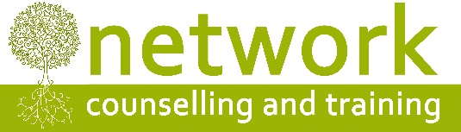

CPD workshop booking form

I wish to reserve a place on the following course:
“Understanding Eating Disorders” [CPD18A] – Friday 26th January – 9.30am to 4.30pm

Name
Address
Post code
Telephone / Mobile
Email address

Payment
£80.00* per person – or £50.00* per person for students, volunteer counsellors and volunteer supervisors – to include refreshments (tea, coffee and biscuits). If you are claiming the reduced rate, please let us know which agency you work for or the course you are studying …………………………………..…………………………………………
* ‘Early bird’ rate (for places booked and paid for by Friday 15th December 2017) £70 per person, £40 for volunteers and students

I am paying £ ………. by: Electronic transfer Cheque

For electronic payments, please pay Network Counselling and Training Ltd
Account number: 61440713 Sort code: 40-14-24 (Please quote your name and CPD18A for reference)
Please make cheques payable to Network Counselling and Training Ltd

IF YOU HAVE ANY ACCESS OR SPECIAL REQUIREMENTS, PLEASE ADVISE US IN GOOD TIME SO WE CAN TRY TO ACCOMMODATE YOUR NEEDS.

Cancellation policy: Please note that we require a minimum of seven days’ notice of cancellation before the date of the workshop, otherwise the full fee will be payable. No part of the fee can be refunded for non-attendance on the day.
Please return your application form to:
The Training Co-ordinator (CPD18A), Network Counselling & Training Ltd
Trinity College, Bishops Close, Stoke Hill, Stoke Bishop, Bristol BS9 1JP (until 31 December 2017)
Elm Park, Filton, South Gloucestershire BS34 7PS (1 January 2018 onwards)

or by email to: training@network.org.uk

