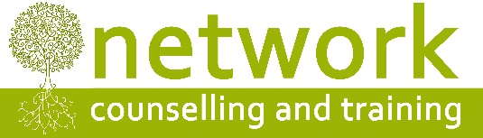
CPD workshop booking form
I wish to reserve a place on the following workshop:
“The Relational Turn” [CPD18D] with Karl Gregory. Friday 13th July 2018 – 9.30am to 4.30pm

Name
Address
Post code
Telephone / Mobile
Email address

Payment
£80.00* per person – or £50.00* per person for students, volunteer counsellors and volunteer supervisors – to include refreshments (tea, coffee and biscuits).
* ‘Early bird’ rate (for places booked and paid for by Friday 8th June 2018) £70 per person, £40 for volunteers and students
If you are claiming the reduced rate, please let us know which agency you work for or the course you are studying …………………………………..……………………………………………………………………..…

I am paying £ ………. by: Electronic transfer Cheque

For electronic payments, please pay Network Counselling and Training Ltd
Account number: 61440713 Sort code: 40-14-24 (Please quote your name and CPD18D for reference)
Please make cheques payable to Network Counselling and Training Ltd
IF YOU HAVE ANY ACCESS OR SPECIAL REQUIREMENTS, PLEASE ADVISE US IN GOOD TIME SO WE CAN TRY TO ACCOMMODATE YOUR NEEDS.

Cancellation policy: Please note that we require a minimum of seven days’ notice of cancellation before the date of the workshop, otherwise the full fee will be payable. No part of the fee can be refunded for non-attendance on the day.
Please return your application form to:
The Training Co-ordinator (CPD18D), Network Counselling & Training Ltd
Elm Park, Filton, South Gloucestershire BS34 7PS

or by email to: training@network.org.uk

NB if you haven’t already given your consent to Network holding your personal data, or otherwise, please also complete the section overleaf.

In line with the new GDPR data regulations, Network Counselling and Training Ltd is required to obtain your consent to our continuing to hold information about you. The personal information we hold about you is: name, address, telephone number and email address. Your personal data is shared only within the staff of Network Counselling and Training in order to manage and maintain our training provision. It will never be shared with anyone else.
You have the following rights:
- The right to access a copy of personal data which Network Counselling and Training holds;
- The right to request that Network rectifies or corrects any personal data if it is found to be inaccurate or out of date;
- The right to request that your personal data is erased. However if we are unable to retain certain elements of your personal data, we may no longer be able to provide you with training.
- The right to restrict or object to our processing information about you, e.g. for statistical or marketing purposes;
- The right to lodge a complaint with the Information Commissioners Office.
By agreeing and signing below, you are giving your consent, to Network holding your information, which we use to enable your training experience, and to maintain our statistics.

- Yes please, I would like to stay in contact with Network.
- No thank you, I do not wish Network to contact me
Signed ………………………………………………………………………….......
Name (printed):……………………………………………………………..…….

