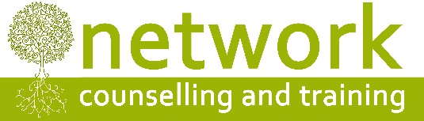
2019 CONFERENCE booking form
“Are We All Mad?” on Friday 10th May 2019
Name
Address
Post code
Telephone/Mobile
Email address

Please indicate your 1st and 2nd choice of workshop:

1st choice (1, 2, or 3)
2nd choice (1, 2, or 3)

Payment
£90.00* per person – or £60.00* per person for students, volunteer counsellors and volunteer supervisors – to include refreshments (tea, coffee, biscuits) and a light lunch.
If you are claiming the reduced rate, please let us know which agency you work for or the course you are studying …………………………………………………………………………………..
*‘Early bird’ rate (for places booked and paid for by Friday 29th March: £80.00 per person, £50.00 for volunteers and students.

I am paying £ ………. by: Electronic transfer Cheque
For electronic payments, please pay Network Counselling and Training Ltd
Account number: 61440713 Sort code: 40-14-24 (Please quote your name and CPD19C for reference)
Please make cheques payable to Network Counselling and Training Ltd

IF YOU HAVE ANY ACCESS OR SPECIAL REQUIREMENTS, PLEASE ADVISE US IN GOOD TIME SO WE CAN TRY TO ACCOMMODATE YOUR NEEDS.
Cancellation policy: Please note that we require a minimum of seven days’ notice of cancellation before the date of the workshop, otherwise the full fee will be payable. No part of the fee can be refunded for non-attendance on the day.
Please return your application form to:
The Training Co-ordinator, Network Counselling & Training Ltd
Elm Park, Filton, Bristol BS34 7PS
or by email to: sue.woodhead-marsh@network.org.uk

