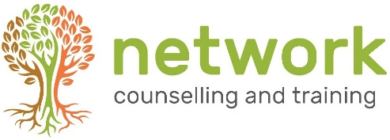

‘BEING THERE’ (BT20A)
A 12-week introduction to listening and counselling skills

Thursdays 6.30pm to 9.00pm – 8 January to 1 April 2020 (half term 19 February)
at Network Counselling &Training, Elm Park, Filton, Bristol BS34 7PS

Closing date for applications: 20 December 2019
(Late applications will be considered subject to the availability of places)

Name
Address
Post code
Telephone / Mobile
Email address
Course fee £225  (includes a non-returnable deposit of £20) | Are you paying: (a) single payment (b) three instalments
 | Are you paying by: (a) BACS (b) Cheque

PAYMENT INSTRUCTIONS
(1) If you are paying in one lump sum, please do this at the point of booking.
(2) If you are paying in three instalments by BACS, please make the first payment at the point of booking, and the remaining payments on or before 1 Feb 2020 and 1 Mar 2020 (£75 each instalment).
(3) If you are paying three instalments by cheque, please enclose all three cheques with your application - one with the current date, one dated 1 Feb 2020 and one dated 1 Mar 2020 (£75 each instalment).
For electronic payments, please pay Network Counselling and Training Ltd
Account no: 61440713 Sort code: 40-14-24 (quoting your name and BT20A for reference)
Cheques to be made payable to Network Counselling & Training Ltd please.
CANCELLATION: A confirmed booking cancelled up to 14 days prior to the start of the course will be refunded the full amount (minus deposit). Otherwise the full fee remains payable. If the course is cancelled by Network at any point, all fees will be refunded.
Please return completed forms to the Training Coordinator at the address below
or email to: training@network.org.uk
NB Please let us know if you have any special requirements, and be aware that we may need more than a few days’ notice in order to ensure that we are able to meet these.
Your signature: | Date:

How did you hear about this course? Network website Friend/colleague leaflet/poster at church
Other (please state)
Network Counselling & Training Limited
Elm Park, Filton, Bristol BS34 7PS
Tel 0117 950 7271 Email training@network.org.uk www.network.org.uk

Registered Charity no. 292801 Company Limited by Guarantee Reg. no. 1951370

