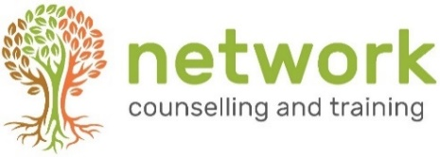

‘BEING THERE’ (BT22)
A 12-week introduction to listening and counselling skills

Wednesdays 6.30pm to 9.00pm – 14 September to 7 December 2022 (half term 26 October)
Venue: Network Training, Elm Park, Filton, Bristol BS34 7PS
Closing date for bookings: 6 September 2022
(Late bookings considered subject to the availability of places)

Name
Address
Post code
Telephone / Mobile
Email address
Course fee £250  Payable by BACS  (includes a non-returnable deposit of £20) | Are you paying: (a) single payment □ (b) three instalments □

PAYMENT INSTRUCTIONS
(1) If you are paying in one lump sum, please do this at the point of booking.
(2) If you are paying in three instalments, please make the first payment of £90 at the point of booking, and the remaining payments, of £80 each, on or before 1 Oct 2022 and 1 Nov 2022.
For electronic payments, please pay Network Counselling and Training Ltd
Account no: 61440713 Sort code: 40-14-24 (quoting your name and BT22 for reference)
CANCELLATION: A confirmed booking cancelled up to 14 days prior to the start of the course will be refunded the full amount (minus deposit). Otherwise the full fee remains payable. If the course is cancelled by Network at any point, all fees will be refunded.

Please return completed forms to the Training Coordinator at the address below
or email to: training@network.org.uk
NB Please let us know if you have any special requirements, and be aware that we may need more than a few days’ notice in order to ensure that we are able to meet these.
Your signature: | Date:

How did you hear about this course? Network website □ Friend/colleague □ leaflet/poster at church □
Other (please state)
Network Counselling & Training Limited
Elm Park, Filton, Bristol BS34 7PS
Tel 0117 950 7271 Email training@network.org.uk www.network.org.uk

Registered Charity no. 292801 Company Limited by Guarantee Reg. no. 1951370

