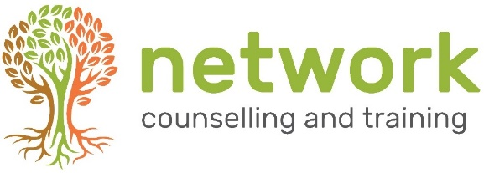
APPLICATION FORM

‘ON BECOMING A PERSON’ (2020)
“A Journey towards greater self-awareness, self-understanding, and self-acceptance”
Venue: Network Training, Elm Park, Filton, Bristol BS34 7PS
Wednesday 22nd April – Wednesday 15th July 2020 (half-term break 27th May 2020)
from 6.30 – 9.00 pm
Course fee £240 - includes a £25 non-returnable deposit.
Can be paid in one lump sum or three instalments.
Closing date for applications: Wednesday 8th April 2020
(late applications will be considered subject to the availability of places)

Name
Address
Post code
Telephone / Mobile
Email address

1. Personal Statement
Please tell us what has drawn you to this course and what you are hoping to achieve from it.

continued over …

Health /additional support *
If you have an ongoing health condition, a mental health diagnosis, a disability or have learning support needs, we recommend that you let us know as early as possible. We will contact you to discuss your requirements in relation to the selected course, and discuss the support and facilities available, this will ensure that we are able to offer you the support you need.

* As part of this course, you will be invited to reflect upon your own life. This can feel personal and revealing. We are looking for you to be reasonably emotionally robust. We suggest you consider the impact that significant life experiences (such as a close personal bereavement, mental health issues, personal illness or recovering from addiction) have had on your life, and how these may impact you whilst on a personal development course. If necessary, we encourage you to join the training when you’ve had time to rebalance and you feel emotionally ready for the course.

Please return completed forms to the Training Coordinator at the address below
or email to: training@network.org.uk

Your signature: | Date:

How did you hear about this course? Network website Friend/colleague leaflet/poster at church
Other (please state)
Network Counselling & Training Limited,
Elm Park, Filton, Bristol BS34 7PS
Tel 0117 950 7271 Email training@network.org.uk www.network.org.uk

Registered Charity no. 292801 Company Limited by Guarantee Reg. no. 1951370

