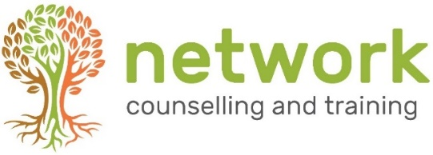

CPD workshop booking form

I wish to reserve a place on the following course: “Embodying the Core Conditions” [CPD21A]. Friday 1st October 2021 - 9.30am to 4.30pm

Name
Telephone / Mobile
Email address

Payment
£85.00* per person – or £55.00* per person for students, volunteer counsellors and volunteer supervisors – to include refreshments (tea, coffee, biscuits).

If you are claiming the reduced rate, please let us know which agency you work for or the course you are studying …………………………………………………………………………………..

*‘Early bird’ rate (for places booked and paid for by Friday 20th August: £75.00 per person, £45 for volunteers and students.

I am paying £ ………. by: Electronic transfer Cheque
For electronic payments, please pay Network Counselling and Training Ltd
Account number: 61440713 Sort code: 40-14-24 (Please quote your name and CPD21A for reference)
Please make cheques payable to Network Counselling and Training Ltd

IF YOU HAVE ANY ACCESS OR SPECIAL REQUIREMENTS, PLEASE ADVISE US IN GOOD TIME SO WE CAN TRY TO ACCOMMODATE YOUR NEEDS.

Cancellation policy: Please note that we require a minimum of seven days’ notice of cancellation before the date of the workshop, otherwise the full fee will be payable. No part of the fee can be refunded for non-attendance on the day.

Please return your application form to:
The Training Co-ordinator, Network Counselling & Training Ltd
Elm Park, Filton, Bristol BS34 7PS

or by email to: sue.woodhead-marsh@network.org.uk

