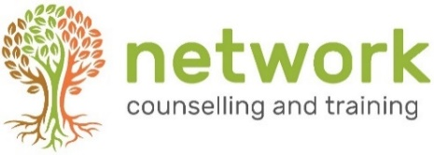

BEING THERE’ (BT24)
A 12-week introduction to listening and counselling skills

Tuesdays 6.30 to 9.00pm – 16 April to 9 July 2024
(half-term 28 May)
Venue: Network Training, Elm Park, Filton, Bristol BS34 7PS
Closing date for bookings: Wednesday 3 April 2024
(Late bookings considered subject to the availability of places)

Name
Address
Post code
Telephone / Mobile
Email address
Course fee £295  (includes a non-returnable deposit of £25) | How would you like to pay?: (a) single payment □ (b) three instalments □

PAYMENT INSTRUCTIONS
(a) A single payment will be due on enrolment.
(b) For three instalments: £95 on enrolment, £100 on May 1, £100 on June 1.
A payment link will be sent to you on receipt of your booking form. Your place will be secured when payment is made.
CANCELLATION: A confirmed booking cancelled up to 14 days prior to the start of the course will be refunded the full amount (minus deposit). Otherwise the full fee remains payable. If the course is cancelled by Network at any point, all fees will be refunded.

Please return completed forms to the Training Coordinator
Email: training@network.org.uk
NB Please let us know if you have any special requirements, and be aware that we may need more than a few days’ notice in order to ensure that we are able to meet these.
Your signature: | Date:

How did you hear about this course? Network website □ Friend/colleague □ leaflet/poster at church □
Other (please state)
Network Counselling & Training Limited
Elm Park, Filton, Bristol BS34 7PS
Tel 0117 950 7271 Email training@network.org.uk www.network.org.uk

Registered Charity no. 292801 Company Limited by Guarantee Reg. no. 1951370

