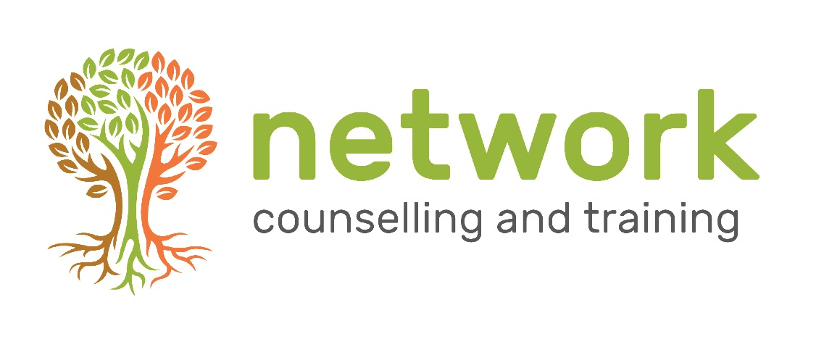

Counselling Placement Application form (External student)

Please return this form to:
Clinical Lead
Network Counselling & Training
Elm Park
Filton, Bristol
BS34 7PS
Or email to: Jamie.de.Carvalho@network.org.uk

Personal details (in capitals please)

Full name:

Title:

Address:

Post code:

Telephone no: Home:

Work:

Mobile:

E-mail:

We welcome a full CV in addition to your completed application form. CV enclosed:

Counselling training - completed
Please give details of the counselling training you have completed so far and include the following information:
- The principal counselling or psychotherapy qualification that you are working towards

- Nature of the course(s)

- The name of the training organisation(s)

- Number of hours of training (tuition)

- Dates of the training course(s)

- Date of expected qualification

Counselling experience
Please give details of your counselling experience including the length of time you have been counselling as a student counsellor (if relevant); an estimate of counselling hours completed and range of client issues you have worked with.

How would you describe the counselling model that informs your practice?

Do you have areas of particular interest or expertise?

Work experience
Please give details of any other work experience you think is relevant to the role (e.g., any that have involved listening or caring work).

Qualifications
Please give brief details of any other relevant qualifications you hold

Faith and Spiritual Journey
Network is an organisation with a Christian ethos, which consciously tries to integrate the spiritual dimension of human experience into our training and counselling. Please give an indication of your own faith or spiritual background if applicable. (A faith or spiritual background is not essential)

Please comment on your ability to work closely with people from faith traditions different to your own.

Have you read, and are you happy to work within Network’s Ethos and Values Statement?

Medical History
To support you in your work at Network, please indicate below any significant health issues that may impact your work.

What interests you about working as a volunteer at Network?

Other supporting information
If there is any further information which you think may be helpful to us in considering your application, please type it on a separate sheet entitled ‘Other supporting information’ and send it with your application.

Please inform the Head of Counselling regarding anything which is likely to be picked up on your DBS disclosure so that this can be discussed at interview. This should be sent under separate cover and clearly marked private and confidential.

Other supporting information attached? Yes/No

I would like to be considered for the position of volunteer counsellor at Network.
I am willing to commit to the agency for at least 12 months, work with a minimum of three clients per week, attend regular supervision and undertake ongoing continuing professional development
I agree to accept and work within the:
- ‘Ethical Framework for the Counselling Professions’ (British Association for Counselling & Psychotherapy)
- Agency guidelines as outlined in the Counselling Placement Agreement
- Ethos and Values Statement

Signature of applicant:

Date of application:

References

Please provide details of referees Network may contact once a conditional offer has been made. If you are unable to provide a supervisor’s reference, a personal referee is acceptable.

Tutor’s reference

Name:

Position:

Email:

Postal Address:

Post code:

Daytime Telephone No:

Supervisor’s reference

Name:

Email:

Postal Address:
Post code:

Daytime Telephone no:

Personal reference only needed if you are unable to provide details of a supervisor
Name:

Email:

Postal Address:

Post code:

Daytime Telephone no:

